Home Means Nevada, Inc.
President – Perry Faigin
Vice-President– Vacant
Member at-large-Shannon Chambers
Board Member– Jennifer Yim
Board Member – John McCormick

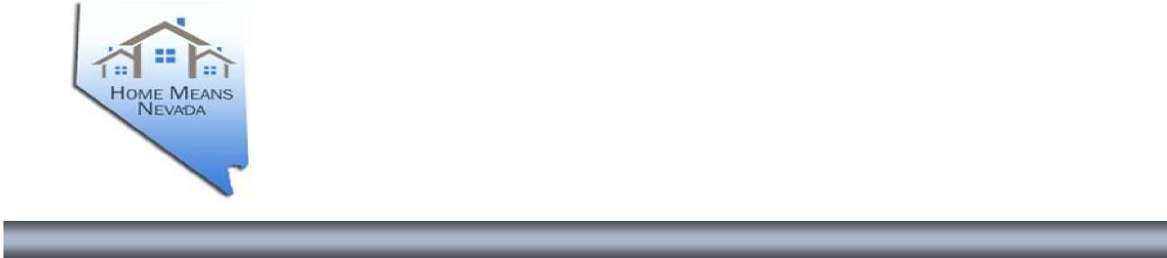
Board of Directors
Home Means Nevada, Inc.
A Non-Profit Entity Established by the
State of Nevada, Department of Business and Industry
Board of Directors Public Meeting
April 3, 2025, at 9:30 A.M.
Meeting Location: Teleconference
MEETING MINUTES
- Call to order and Roll Call.
Perry Faigin, President, called the meeting to order at approximately 9:33 a.m. Roll Call and Quorum.
The following were in attendance:
Perry Faigin, President, (By Telephone)
Shannon Chambers, Member at-large, (By Telephone) (joined at 9:46 AM)
John McCormick, Board Member, (By Telephone)
Jennifer Yim, Board Member, (By Telephone)
Michelle Crumby, Operations Manager, (By Telephone)
Lana Smith, Project Assistant, (By Telephone)
Cynthia Ravenholt, Project Assistant, (By Telephone)
Colleen Platt, Legal Counsel, (By Telephone)
- Public Comment.
There was no public comment.
3. “For Discussion and Possible Action” Approval of Minutes from April, 9, 2024.
John McCormick, Member at-large, made a motion to approve the minutes as written. The motion was seconded by Jennifer Yim, Board Member. There was no discussion on the motion, and it passed unanimously.
- “For Discussion” Update on Foreclosure Mediation Program and fiscal status.
Operations Manager, Home Means Nevada, Inc, Michelle Crumby.

Michelle Crumby, Operations Manager, through February 2025 the notice of defaults recorded (NOD’s) was 1,798, 1,328 filed in Clark County and Washoe 197.
75 Petition of Foreclosure Mediation
cases filed in District Court, 808 Foreclosure Mediation Certificates issued,752 no Petition for Foreclosure Mediation case filed, 56 of these cases no agreement reached or Court Order, or at a latter date. Year to date district court complete cases received by HMN are 183. 124 resulted in no certificate to issue per agreement or court order. 59 resulted in certificate issuance per agreement or court order. No questions. Perry Faigin, President, Fiscal and Program Overview. Overview of efforts to secure contingency funds from IFC; funding remains unstable. January 2025 contingency award expected to sustain operations through June 2025. HMN staff reduced to two; cost-saving efforts include portal revaluation and office relocation planning. Legislative resistance to transferring program responsibilities. Potential legal/statutory changes discussed
Board Discussion: Shannon Chambers, Board Member and John McCormick, Board Member to engage legislative contacts. Jennifer Yim, Board Member, comments about foreclosure timelines (currently faster). Cynthia Ravenholt, Project Assistant, noted increased defaults on newer loans with higher interest rates.

5. “For Discussion and Possible Action” Approval of 2024 Audit and Financial
Statement and Tax Return. President, Perry Fagin, Home Means Nevada, Inc.

No questions, Motion to approve, Board Member Jennifer Yim, made a motion
to approve, Board Member, Shannon Chambers second the motion. Motion passed.

6. Public Comment.

There was no public comment.
7. Adjournment.
The meeting was adjourned at 10:20 a.m.

2

